**Why Is Electronics Recycling So Important In The World?**

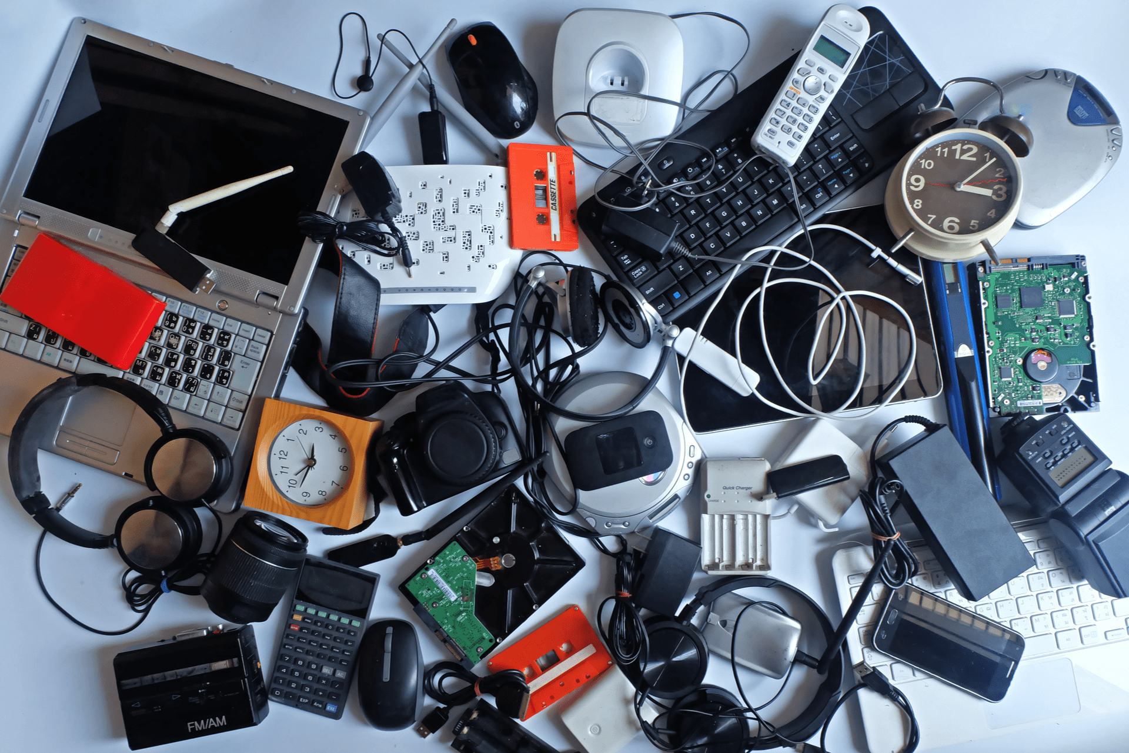

At Recycle Pro, we are passionate about encouraging people to recycle their old or broken devices. While we recognise that most people understand that recycling is beneficial to the environment, we believe that there are some details that everyone should be aware of that drive home the necessity of recycling.

Let's look at five essential reasons why electronics recycling is important around the world, and how Recycle Pro can help you improve your local environment.

**It is always better for the environment to have fewer landfills**

Landfills could be a good site for regular rubbish to decompose. However, electronics and other objects that should not be dumped in landfills frequently end up there.

Electronics recycling saves landfill space and helps to avoid the spread of poisons like methane, mercury, and lead, as well as other environmental concerns that e-waste causes.

Electronic recycling not only keeps landfills cleaner, but it also minimises landfill clutter and reduces the need to generate more when space becomes scarce.

1. **waste is one of the most polluting types of waste**

While electronics are useful in our daily lives, when they are discarded, they become a direct source of local air pollution. E-waste from landfills that rises into the atmosphere spreads toxic substances into the air, which can have severe consequences for the human respiratory system.

A cloud of contaminated air in a local setting is all it takes for humans to inhale it and be exposed to mercury, cadmium, and other chemicals over time.

Devices recycling repurpose outdated electronics while preventing e-waste from entering the atmosphere.

**Electronic recycling is good for the environment.**

E-waste not only has a significant impact on the Earth's air quality, but it also has a direct impact on the environment on the ground. When electronics are thrown in a landfill to be disposed of, their poisons can contaminate the soil and groundwater in the area surrounding the landfill.

Returning devices to an R2 Certified recycling centre helps to mitigate the dangers that e-waste poses to sea and land organisms that rely on healthy soil and water for survival.

**Recycling helps to preserve natural resources**

Electronics are items made from valuable materials such as natural resources that are in short supply. Our valuable electronics contain oil, iron, gold, copper, and other natural resources.

Unfortunately, if these resources are routinely collected to make new devices, they will eventually run out. Recycling electronics aids in the decomposition of obsolete cell phones, laptops, hard drives, and other electronic devices into "new" materials for new electronic items. This helps the environment immediately by reducing the need for farm-specific resources to manufacture new devices.

**Economic Benefits of Recycling**

Everyone in the world enjoys saving money in any way they can. Recycling electronics serves to provide consumers with a valuable option to do so on new equipment.

Recycling items not only saves energy and resources, but it also lowers the cost of manufacture, making recycled products more accessible to customers.

**With Recycle Pro, you can help save the environment.**

Recycle Pro is here to help if you're part of a company that wants to do its part for the environment by [recycling old electronics](https://www.recyclepro.co.uk/). We are a group of certified recycling professionals who specialise in safe processes, complete data destruction, and assisting consumers in profiting from their recyclables.

To learn more about our recycling process or to schedule your first recycling pickup or drop-off with Recycle Pro, please contact us.